

**BSc (Hons) in Information Technology**

# IT3060 – Human Computer Interaction Year III, Semester II, 2020

**Tutorial Cover Sheet**

|  |  |
| --- | --- |
| **Tutorial No** | Tute 1 |
| **Batch No** |  |
| **Group No** |  |



|  |  |  |
| --- | --- | --- |
|  | **Student Registration Number** | **Student Name /(Contact Number)** |
| **1** | **IT18110494** | **Yatagama H.C** |

1. What is Human Computer Interaction (HCI) and what is the importance of having HCI?

Human Computer interaction is the study of how people interact with the computing technology, furthermore,” HCI is the discipline concerned with the designed evaluation, and the implementation of interactive computer systems for the human use and with the study of major phenomena surrounding them”**.**

Importance of having HCI

* Increase in productivity
* Reduce the need for training, workshops, user manuals, knowledge transfers
* Good quality product
* Customer satisfaction
* Increased market share

1. What is user experience (UX), Explain with an example?

"User experience" encompasses all aspects of the end-user's interaction with the company, its services,

and its products.”

For an example if a company requests to make a web application for their company we should take care of the user’s needs, their limitations, what they value and their abilities. Here the user needs refer to what they expect from the product we make, the web application that we developed must cater their requirements, also if the company has given us limitations we should abide to those limitations and develop the application. Also in an company or an organization there are different people wqith different abilities so we should take into consideration their abilities and develop our product.

1. What is user centered design (UCD)?

User-centered design is an iterative design process in which designers focus on the users and their needs in

Each phase of the design process.

1. Illustrate and explain User Centered Development Process(UCD)

This is an iterative process that consist of mainly 4 phases,

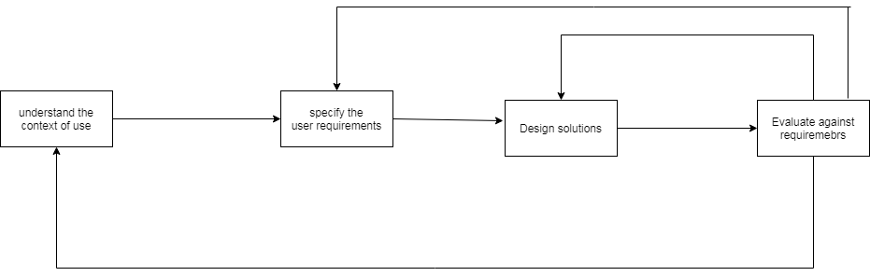

* Here as the first step designers attempt to understand the context in which users may use a system. Subsequently, identify and specify the users’ requirements. A design phase follows, where in the design team develops solutions. The team then proceed to an evaluation phase and assess the outcomes of the evaluation against the users’ context and requirements to check how well a design is performing. Then the team makes further iterations of these four phases, continuing until the evaluation results are satisfactory.

1. Explain the four HCI contexts

The 4 HCI contexts respectively are:

* Physical Context –

The physical context includes everything which is measurable in the environment of the system with which the user interacts. • This includes temperatures, noise levels, lighting situations, traffic conditions, etc.

* Computing Context

The computing context contains everything related to computational resources. • This can include things such as available networks, network bandwidth, communication costs and nearby computational resources such as printers or fax machines.

* Time Context

The time context covers relevant information related to time such as absolute time, date, day of the week

and the season.

* User Context

The user context (also known as personal context) represents information about the end-user, which I interacts with the system. This includes information such as:

• user profile (age, preferences)

• user’s location (absolute position, indoors, outdoors) and orientation

• nearby objects • people nearby

• social situation.

1. List the Social Issues Influencing HCI Design and Use

1 Privacy and Security Issues

2. Education and Computer Literacy Level

3. Business Needs

4. Gender Differences

5. Age Difference 6. Government Rules, Needs, Policies

6. Technology Diversity /Technological innovation

1. What is Multi-Cultural Interaction?

Different cultures have different approaches to interact with the computers which may causes different types of problems. But Many software companies and designers treat other cultures as inconveniences that cost money to deal with and as a result, the differences in people are ignored. Therefore, people need to adapt to the interfaces instead the opposite. Differing cultures requires careful attention to language, colors, layouts, visual depictions, and cultural sensitivity. These differences can increase the complexity of empirical evaluations. This is known as the multicultural interaction.

1. Explain how to design for the following disability types?

• Visual disabilities

• Auditory disabilities

• Motor disabilities

• Cognitive disabilities

• Visual disabilities

For the people suffering from the visual disabilities we can give the following solutions:

• Braille keyboards

• Special speech software that reads Web pages and other documents aloud.

• Screen magnifiers that fit over a display to magnify the entire screen.

• Avoid the lines / small symbols

• Auditory disabilities

• Documents and screens, you design include access to written versions of the audio material.

• Offer transcriptions for audio files. Hearing-impaired users can’t use software to read voices. So, help them out and include a transcript.

• Offer captions in videos for the hearing impaired.

• Motor disabilities

Use speech inputs (speech recognition) rather than keyboard inputs.

• Sticky Keys: Use of Keyboard from one hand.

• Eye Tracking devices.

• Cognitive disabilities

* Focus on readable content.
* The simpler the language, the easier it will be to read for learning-impaired users